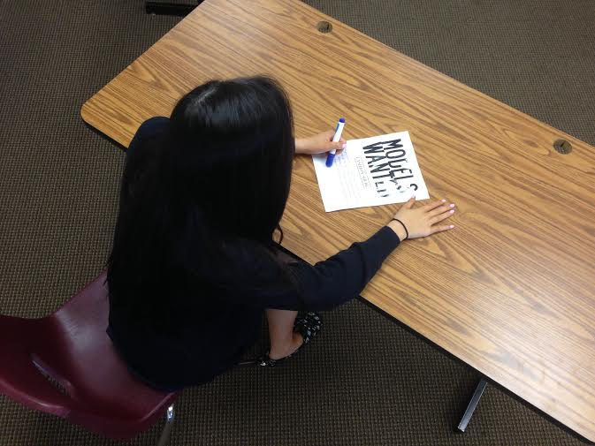
Shot: Establishing – birds view
Action: Dani signs contracts
Dialogue: NONE – upbeat music
Location: Model Agency

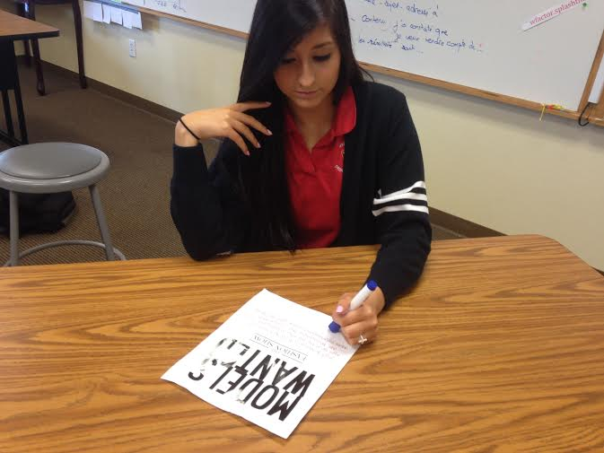
Shot: mid
Action: Continues signing contracts
Dialogue: NONE – upbeat music
Location: Model Agency

Shot: mid
Action:
Dialogue:
Location: Model Agency

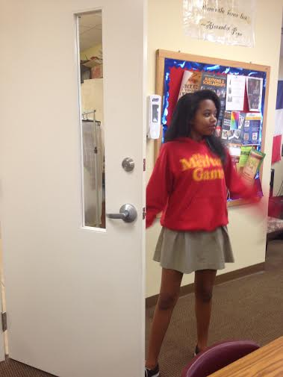
Shot: mid
Action: Zee enters
Dialogue: NONE - Music stops,
Location: Model Agency

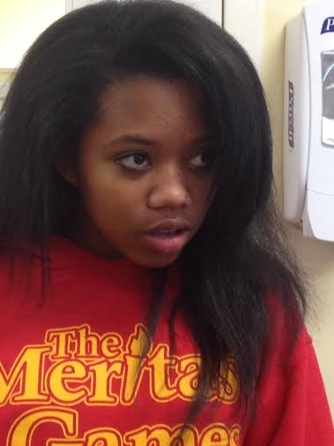
Shot: close up
Action: Zee enters
Dialogue: “Hi”
Location: Model Agency

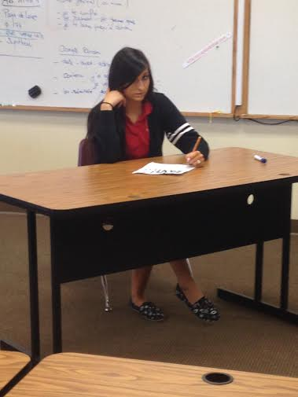
Shot: mid
Action: Dani notices Zee entering
Dialogue: “Hello” – heartbeat comes on
Location: Model Agency

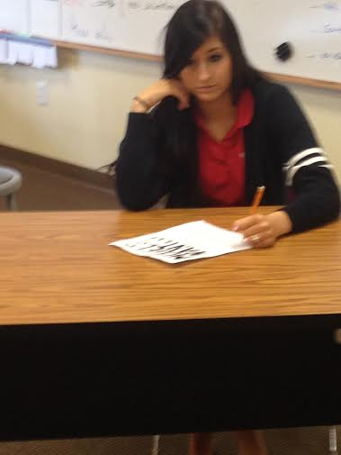
Shot: bust
Action: Dani notices Zee
Dialogue: “Hello”
Location: Model Agency

Shot: over the shoulder
Action: Zee walks in, interrogating Dani
Dialogue: “How’s everything” “Fine I guess” – Heartbeat continue
Location: Model Agency

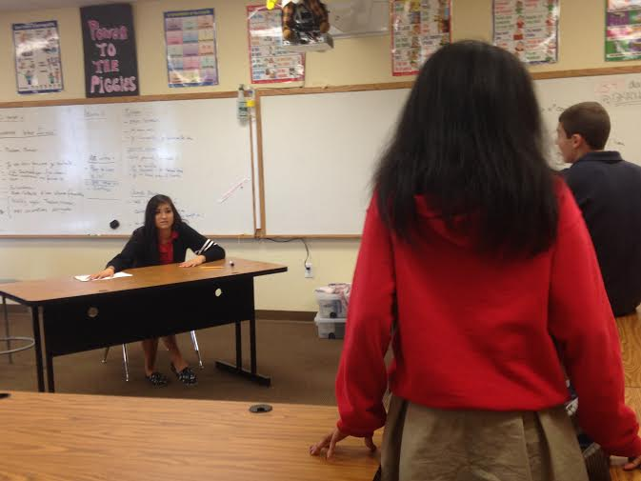

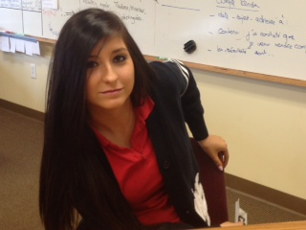
Shot: bust
Action: Dani hides the contract from zee
Dialogue: “Do you know what time is it” Heartbeat continues
Location: Model Agency

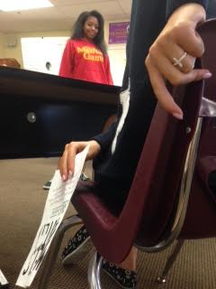

Shot:
Action: Dani contrinues to hide the contract
Dialogue: “No” Heartbeat continues
Location: Model Agency

Shot: Wide
Action: Zee stands in a confidence stance.
Dialogue: “Don’t you have a watch” – heartbeat continues
Location: Model Agency

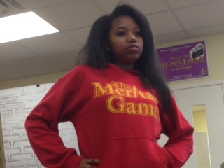

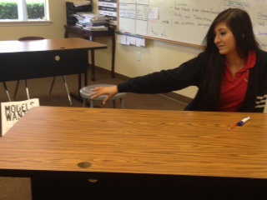

Shot: Bust
Action: Dani throws the contract
Dialogue: “No not on me”, heartbeat continues
Location: Model Agency

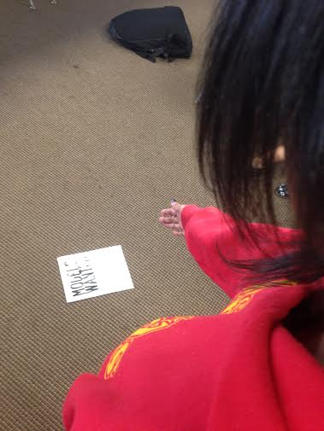
Shot: over the shoulder
Action: Zee reaches for the paper
Dialogue: “Well” “Well what” “What did you do last night” What do you mean” Dramatic music plays
Location: Model Agency

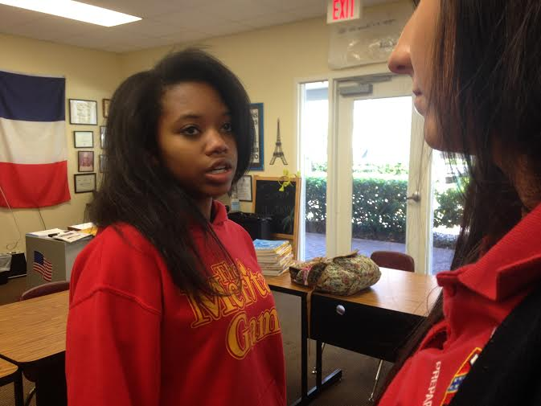
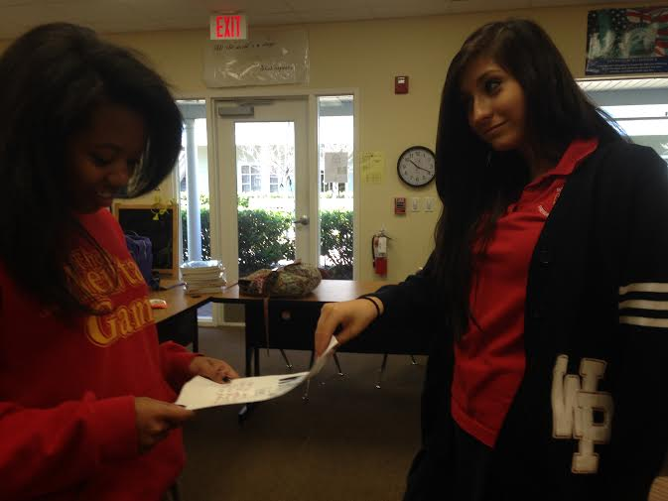
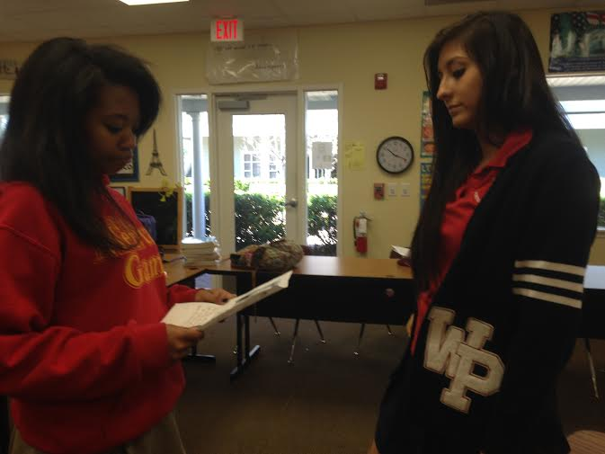
Shot: mid
Action: Zee now holds the paper
Dialogue: “What did you do last night”
Location: Model Agency

Shot: mid
Action: Dani grabs the contract from Zee
Dialogue: “Nothing” “Nothing?” “I said nothing”
Location: Model Agency

Shot: over the shoulder
Action: Zee stares down Dani, and circles her.
Dialogue: “Sorry I asked” Extremely dramatic music plays
Location: Model Agency

