IB SYLLABUS OUTLINE
HIGHER LEVEL STANDARD LEVEL
Consists of 5 compulsory parts Consists of 4 compulsory parts

Part I • Theatre in Performance
An introduction to:
• ensemble work and performance skills
• performance/directing techniques
• acting techniques and characterization
Part I – Theatre in Performance
An introduction to:
• ensemble work and performance skills
• performance techniques
• acting techniques and characterization

Part 2 – Theatre in the World
Studies from an international perspective of selected texts and traditions
• study in detail of at least three contrasting practices
• a minimum of three play texts from more than one theatrical tradition and more than one culture
Part 2 – Theatre in the World
Studies from an international perspective of selected texts and traditions
• study in detail of at least two contrasting practices
• a minimum of two play texts from more than one theatrical tradition and more than one culture

Part 3 – Theatre in the Making
A practical study of the principles and practices of theatre production and an active exploration of extracts and complete play texts as plans for action.
• involvement in at least two productions
• practical engagement/Design and Creation
• imagining a playscript from a director's point of view
• consideration of overall concept and ways of staging
Part 3- Theatre in the Making
A practical study of the principles and practices of theatre production and an active exploration of extracts and complete play texts as plans for action.
• involvement in at least one production
• practical engagement/Design and Creation
• imagining a playscript from a director's point of view
• consideration of overall concept and ways of staging
Part 4 - Individual Project
A project chosen by the candidate in consultation with
the teacher, on a specific aspect of Theatre Arts.
Part 4 - Individual Project
A project chosen by the candidate in consultation with
the teacher, on aspecific aspect of Theatre Arts
Option A or B
Option A only

It is also worth (regularly!) referring back to the Aims and Objectives of the Theatre Arts course, on page 5 of the Theatre Arts Guide

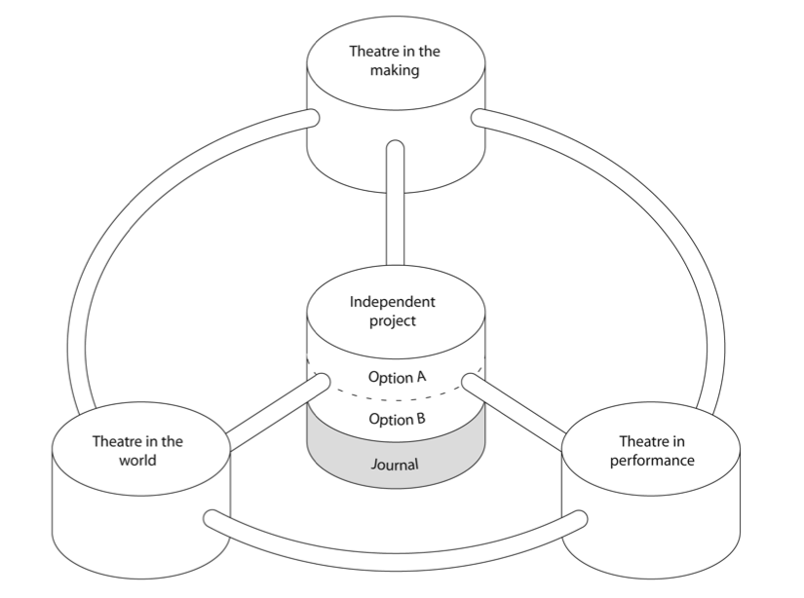

2013-2014

1. Unit title The Cherry Orchard by Anton Checkov
Length 8 weeks (Aug. 16-Oct. 12)
Focal aspect of Unit Theatre in the World/Theatre in the Making/Theatre in Performance (Independent Project-year 2 only)
Course components addressed Realism, directing

Assessment
- Directing one section of text (PS2)
- Analysis of Chekov’s work (PS3)
- Written Pitch (PPP) (PS3) and Presentation of vision and process for The Cherry Orchard (TPPP-5 minutes/3 visuals) (PS1)

Description: In-depth practical exploration of The Cherry Orchard from a director's point of view.

Reading: The Essential Theatre (Brockett), Systems of Rehearsal (Mitter), All the World's a Stage (Harwood), Directors on Directing (Chinoy) and other internet and library resources

2. Unit title Theatrical Explosions
Length 6 weeks (Oct. 14-Nov. 20) Thespian Districts Nov. 21-23
Focal aspect of Unit World Theatre Studies
Course components addressed Research Investigation (RI) /Practical Play Portfolio (PPP)
Assessment

- Practical Play Portfolio practice (in class) (PS1/PS3)
- Research Investigation (Students work independently as Dramaturg on topics of their choosing) (PS1,PS2, PS3)
- Notes made as a result of watching videos, background reading, class discussions (PS3)
- One essay is set at the end of the unit, in preparation for the Research Investigation. Year 2 students must have complete first draft of Research Investigation. (PS1,PS2, PS3)
- TPPP-5 minutes/3 visuals on personal discovery and exploration of this unit. (PS1,PS2, PS3)

Description: Students watch the BBC series All the World's a Stage. They are asked to research various areas of theatre, using the video as a base. They are asked to present questions/areas for discussion, and all students lead these discussions at some point. Students will formulate their Research Investigation question and begin exploring the topic in a practical way. They are encouraged to begin their own reading into one theatrical explosion that takes their interest and to
record along the way possible areas for their Independent Project.

3. Unit title Theatre of the Absurd/Laban movement
Length 6 weeks (Dec.2-Jan. 17)
Focal aspect of Unit Theatre in the World/Theatre in the Making/Theatre in Performance
Course components addressed Character Development, Analysis, Synthesis and Reflection,

Assessment
- Contribution to Theatre (Esslin, Ionesco, Beckett, Albee, Pinter, Genet, Stoppard)
Student presentation/teaching (PS1,PS2, PS3)
- Laban movement (corporeal mime, body language and non-verbal expression) (PS2)

Description: Students are introduced to the main elements of Absurdist Theatre, examples are given from selected texts.
Students then practically explore the genre through individual exploration and presentations. Finally, students are asked to devise and then perform a piece of original theatre based on Absurdist genre.
Reading: The Essential Theatre (Brockett), The Field of Drama (Esslin)

Mid-term Assessment TPPP (Theatre Performance Production Presentation)
Recorded Oral presentation accompanied by visuals reflecting on “journey” thus far. (HL 10 minutes/5 visuals, SL 7 minutes/3 visuals) (PS1,PS2, PS3)

4. Unit title: Oedipus Rex /The Infernal Machine and Adolphe Appia, Gordon Craig, Jacque
Length 6 weeks (Jan. 20–Feb. 28)
Focal aspect of Unit Theatre in the World/Theatre in the Making/Theatre in Performance
Course components addressed Performance skills (Greek Chorus, Voice, mask work, verse), Set design and Lighting
Assessment
- Practical design tasks (lighting and set design) (PS1)
- Development of voice skills (group and individual) (PS2)
- PPP-focus on Set/Lighting (PS1,PS2, PS3)

Description: Practical exploration of the plays and theories, from the perspective of designer. A structured series of voice exercises is included and used in relation to the set text.

Reading: Technical Theatre, Lighting for the stage

5 Unit title Brechtian Theatre
Length 6 weeks (March 3-May 23)
Focal aspect of Unit Theatre in the World/Theatre in the Making/Theatre in Performance
Course components addressed Directing, Performance Skills, Design, Research, Devising, Production, Reflection, Analysis, Synthesis.
Assessment
I. Contribution to Theatre-Independent project devising and presenting original theatre based on genre and techniques learned (PS1,PS2, PS3)

Description: Students are introduced to the main elements of Brechtian theatre, examples are given from selected Brecht texts. Students then practically explore ways of using Brechtian elements in non-Brechtian texts. Finally, students are asked to devise and formally present an original piece of theatre based on these techniques using prescribed IB stimuli (PPP).

Reading: The Essential Theatre (Brockett), The Theatre of Bertolt Brecht (Willett)

Final Summative Assessment: (Oral presentation) TPPP (HL 15 minutes/7 visuals, SL 10 minutes/5 visuals)

Monthly Critique: Being an audience member is essential to their IB Theatre Arts education. IB Theatre Arts students are expected to turn in a critique of a live theatre performance every month. There are many opportunities for students to see theatre and we can go together as a class whenever possible. (PS3)

International Thespian Society: IB Theatre Arts students are expected to participate in District and State Thespian Competitions where they will be able to see many different performances that they will learn from. Please mark your calendars Nov. 21-23 (start of Thanksgiving break) and March 26-29 (during Spring Break). The good news is that they will not miss any school however, I understand that some may wish to plan a family vacation but I must emphasize the extreme value of these events to this course! If you have any questions or concerns please talk with me as soon as possible. (PS1, PS2, PS3)

After School Productions: School productions and performances are an excellent way for IB Students to learn, practice and reinforce their skills. Students in this class will be expected to participate as a designer, crew or performer in at least one WPS production (LS, MS or HS) a semester. This will require time after school and should be considered “homework”. Students may also wish to participate in community theatre productions and will benefit greatly from those experiences. (PS1, PS2)

Important Dates:
- IPP October 1 (year 2 draft 1)
- RI November 20 (year 2 draft 1) (year 1 proposal)
- RI January 14 (year 2 final) (year 1 draft 1)
- Formal PPP January 14-February 11 (year 1 practice/year 2 final)
- IPP March 11 (year 2 Final, year 1 proposal, to be completed in year 2)
- TPPP April 8 (year 2) /May 23 (year 1)

2014-2015
Unit 1 Jean Claude Van Itallie/Open Theatre/August Boal
Unit 2 Theatrical Explosions
Unit 3 Improvisation and Commedia Dell’Arte/Mask/Growtowski/Michael Chekov
Unit 4 Kabuki/Theatre of the Orient
Unit 5 TBA

WPS Assessments
Assessments in theatre arts are notoriously difficult. It is difficult to objectively separate content and quality from effort and passion. The IB Theatre Arts course uses three broad standards to assess student growth and achievement.
- PS1The first area they look at is the student’s abilities and understanding of the creative process or the devising of theatre.
- PS2 The second area is concerned with Production and Performance. The IB provides detailed rubrics that assess the student’s ability to articulate what skills were necessary to produce their performance or production.
- PS3 This is linked with the third important area, Responding. This includes research, reflections, analysis and synthesis of the materials learned and practiced and will be assessed in both written and oral formats.

IB Assessments
Internal
- Independent Project Portfolio (IPP) Written essay
- Theatre Performance Production Portfolio (TPPP) oral presentation
External
- Practical Performance Proposal (PPP) Written Pitch and support materials (designs, play script, production process)
- Research Investigation (RI) Written essay

All of these assignments are completed during the second year of the course, however, students will be given similar practice assignments during year one. IB rubrics are used throughout the course to assess these assignments. See the IB course handbook for details (word count and descriptors vary from HL to SL).

